**Assignment No : 3**

**Title : Feedback and Constraints (College)**

**Feedbacks**

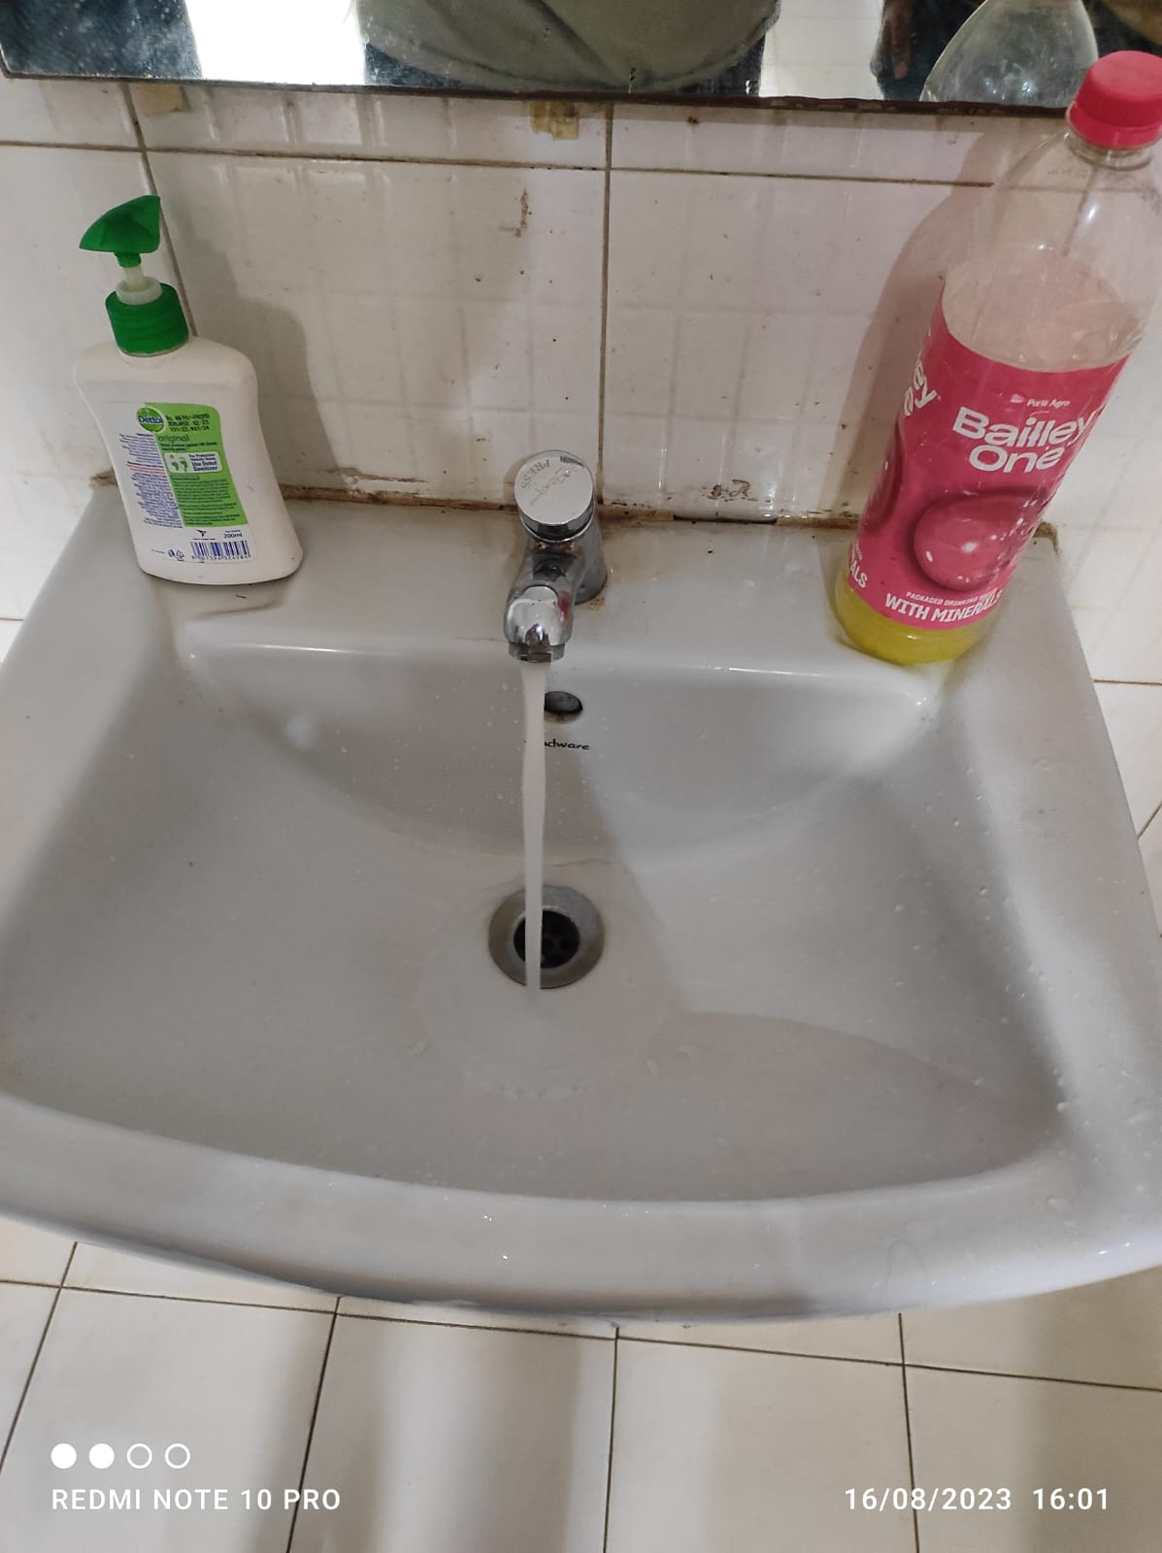

**Source –** A3 3rd floor Boys Toilet

**Feedback –** The tap is turned on by pushing its button and after some time it turns off automatically.

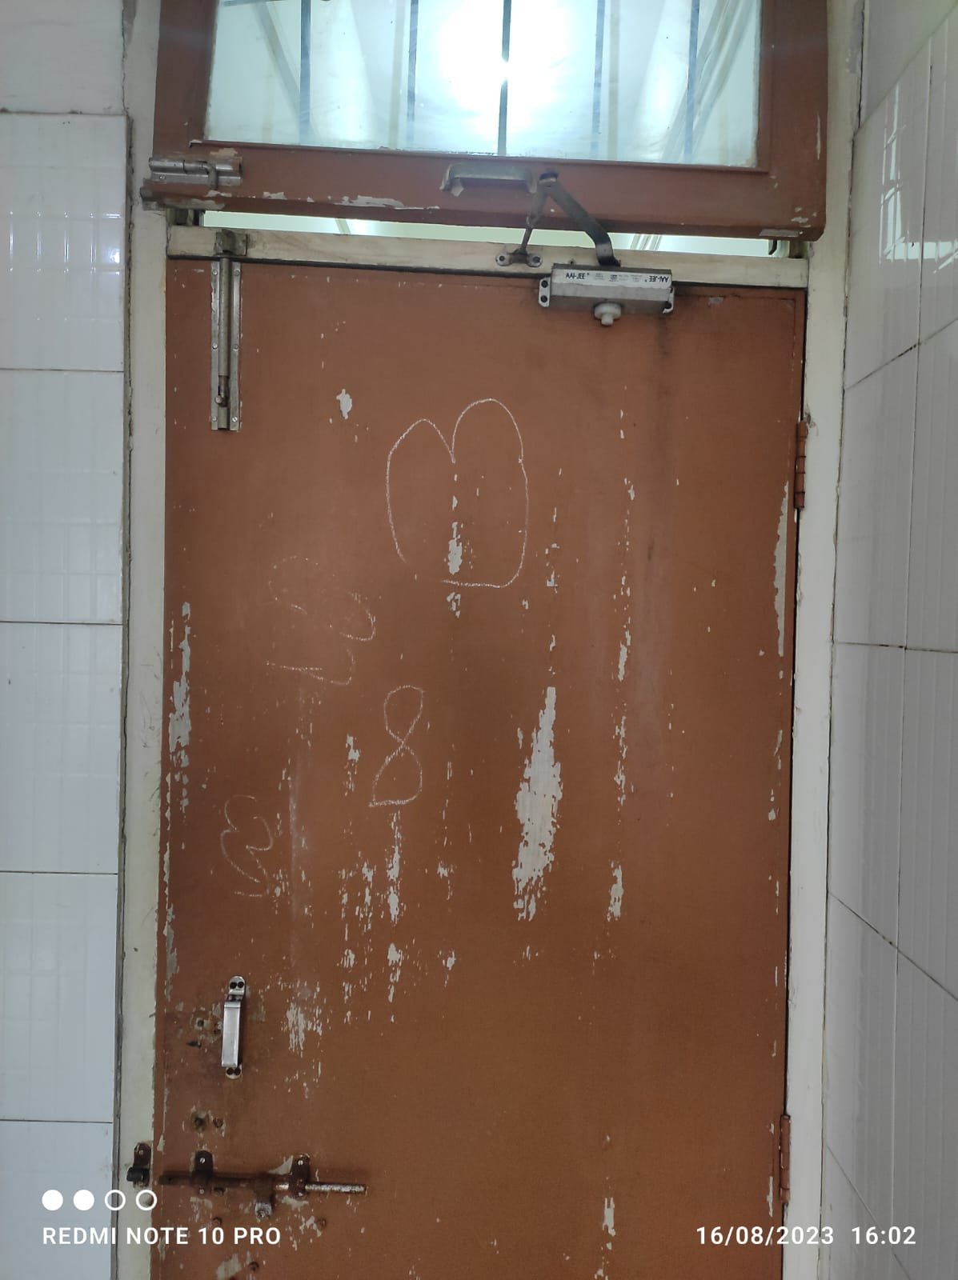

**Source –** A3 3rd floor Boys Toilet

**Feedback –** After opening the door it closes automatically because of the mechanism.

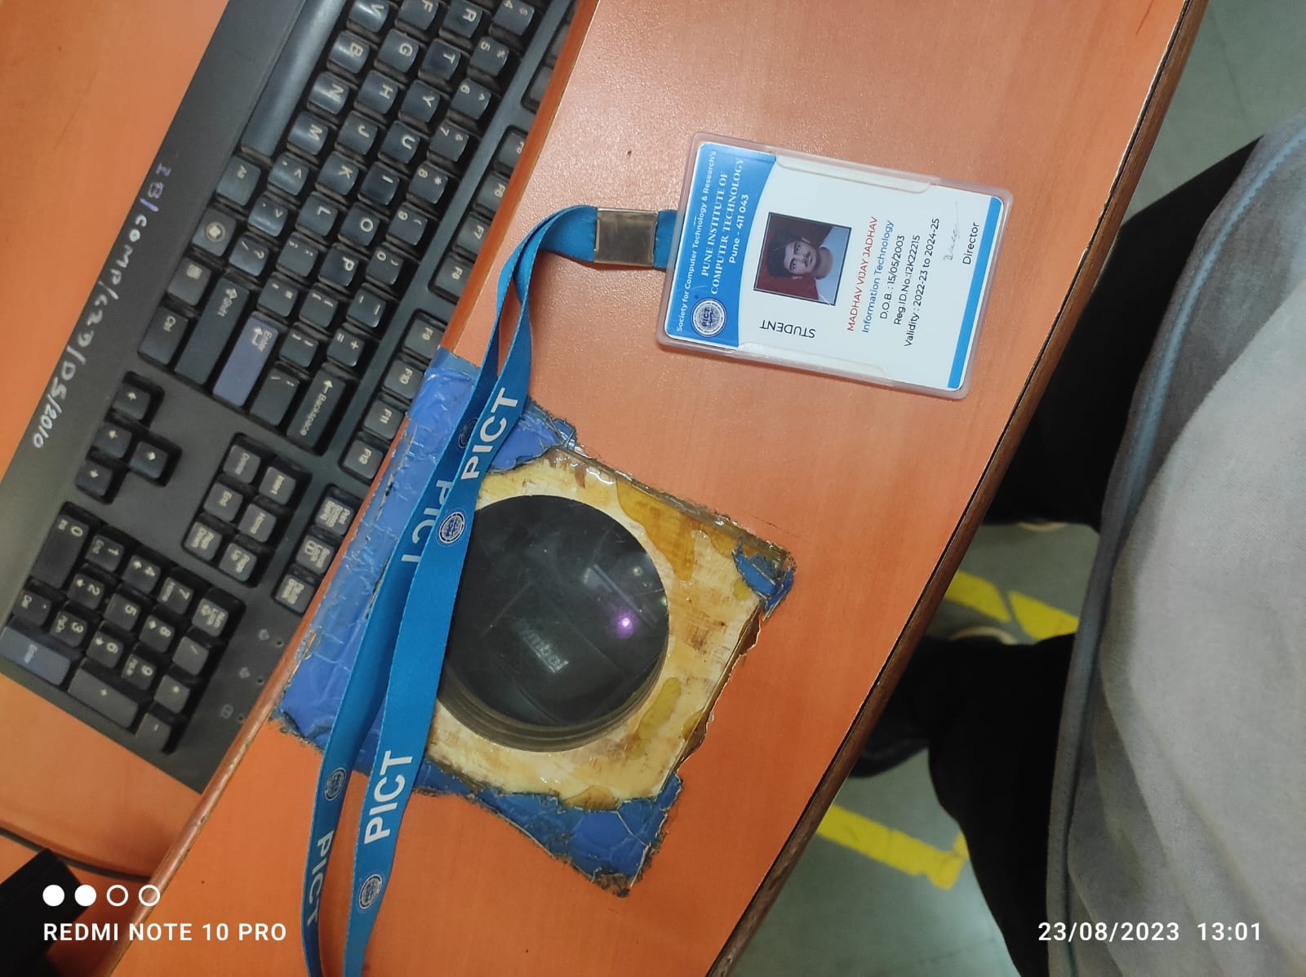

**Source –** Reading Hall

**Feedback –** On successfully scanning your ID Card the machine beeps to indicate that the card is scanned successfully.

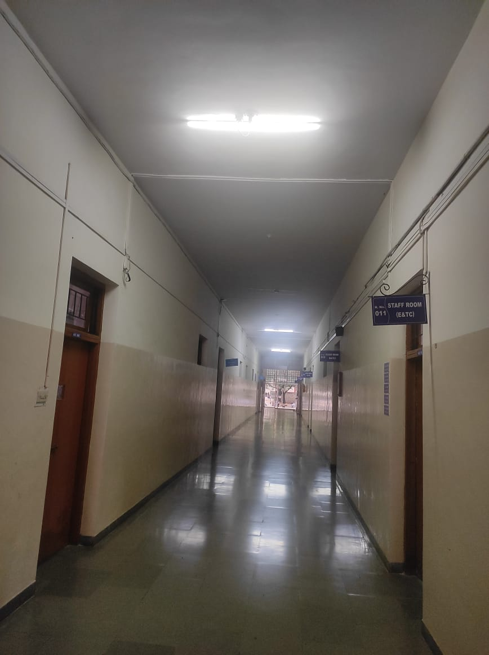

**Source –** A3 Ground Floor

**Feedback –** The lights only turn on when someone is walking through the hallway, thus saving electricity.

**Constraints**

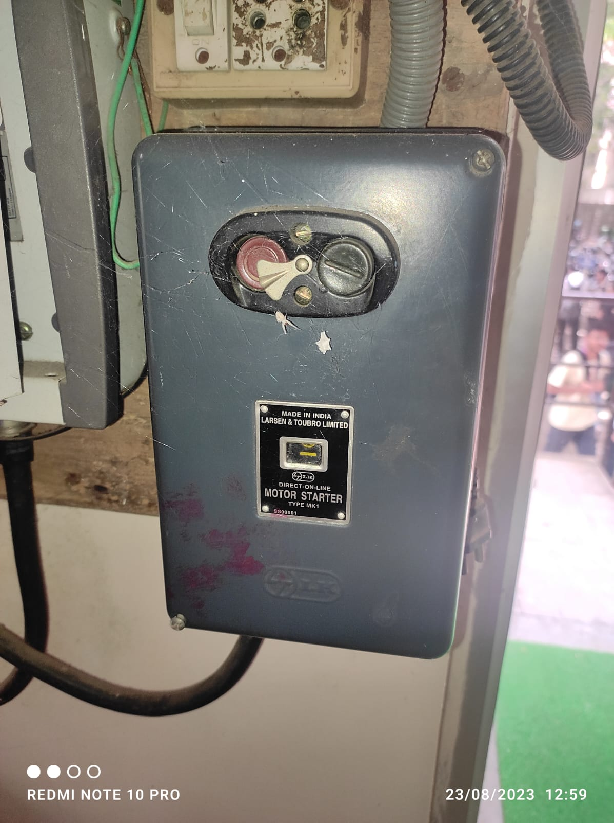

**Source –** A3 Ground Floor

**Constraints –** The button cannot be pressed until the locking mechanism is removed or turned.

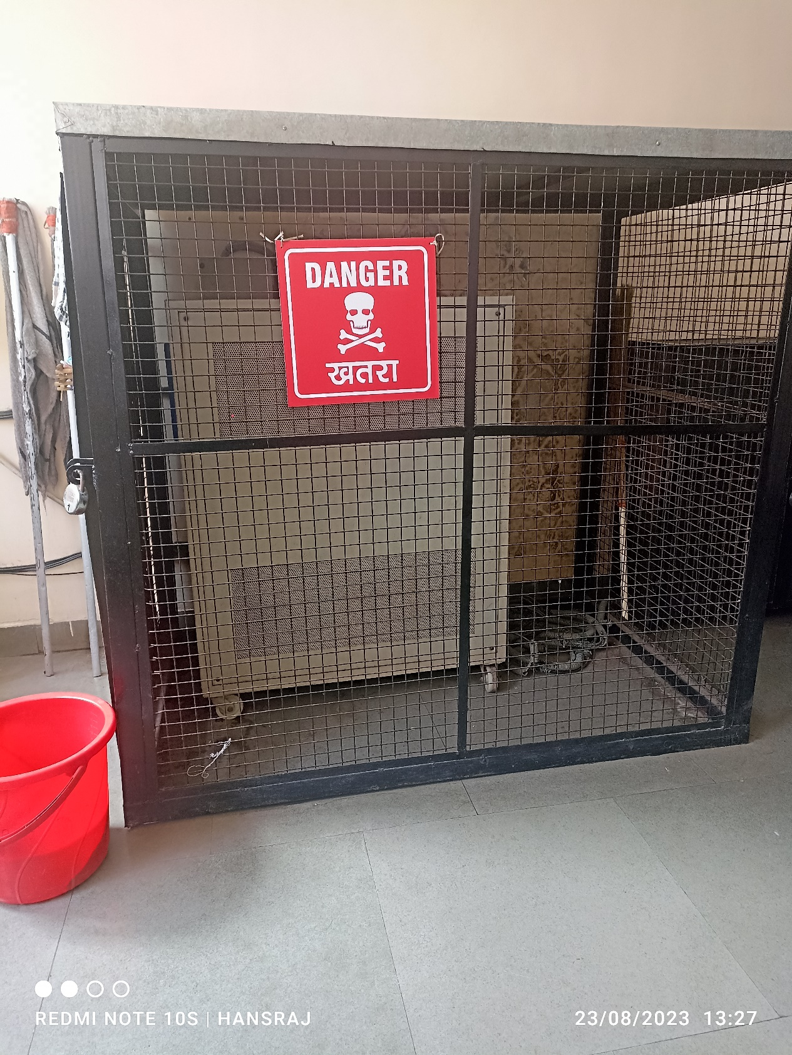

**Source –** A3 Ground Floor

**Constraints –** The cage prevents students from touching the machine as it might electrocute someone.

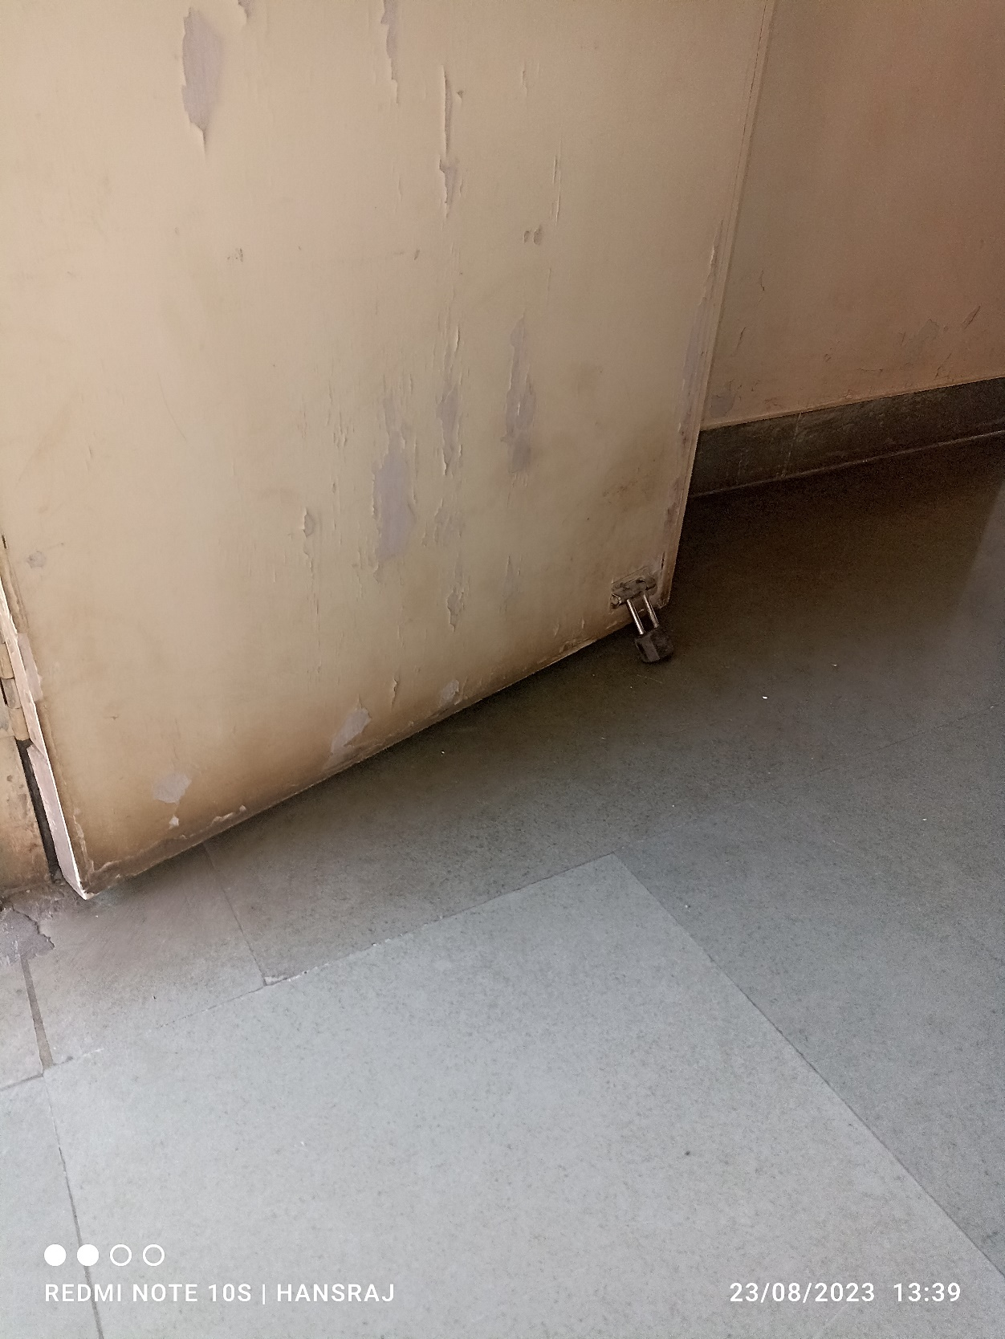

**Source –** A3 Classroom

**Constraints –** The Stopper prevents the door from closing when it should not be closed.

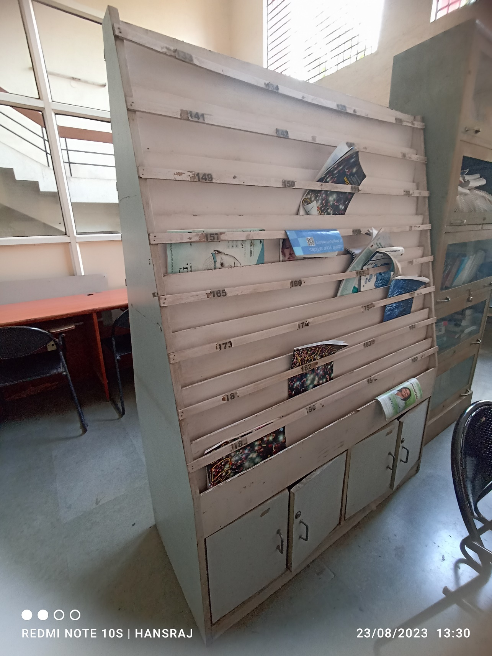

**Source –** A1 Reading Room.

**Constraints –** The strips on the magazine shelf prevents the magazine from falling.

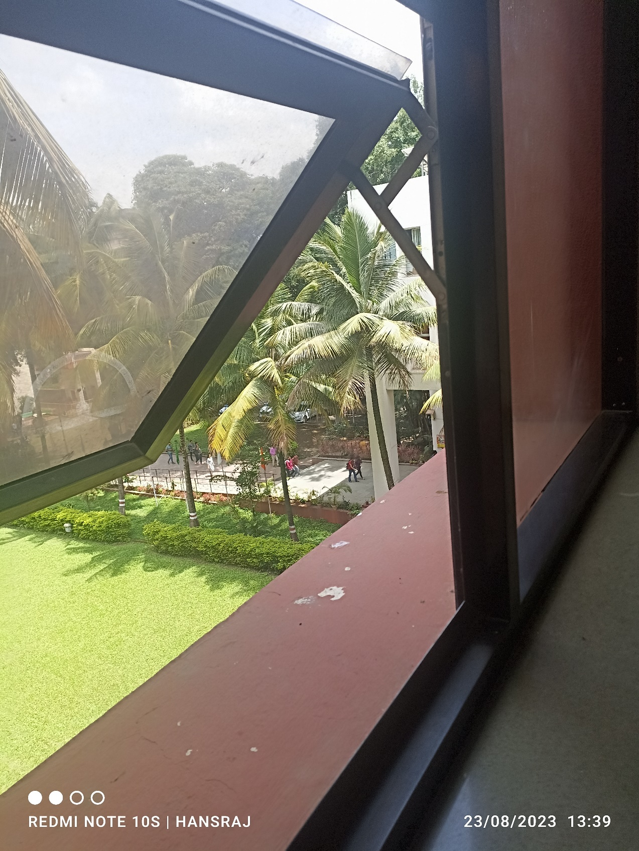

**Source –** A3 to A1 Hallway

**Constraints –** The Hinge prevents the window from closing so that it can remain open.